The INTERNATIONAL NETWORK for the PREVENTION of ELDER ABUSE
For more information, please visit: www.INPEA.net

World Elder Abuse
Awareness Day
~ June 15, 2011 ~

My World... Your World... Our World - Free of Elder Abuse

__________________________________________________
Event Title

__________________________________________________
Date & Time

__________________________________________________
Location
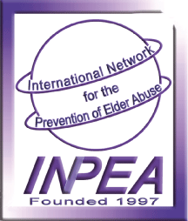
This text box to insert your logo and/or other info.
